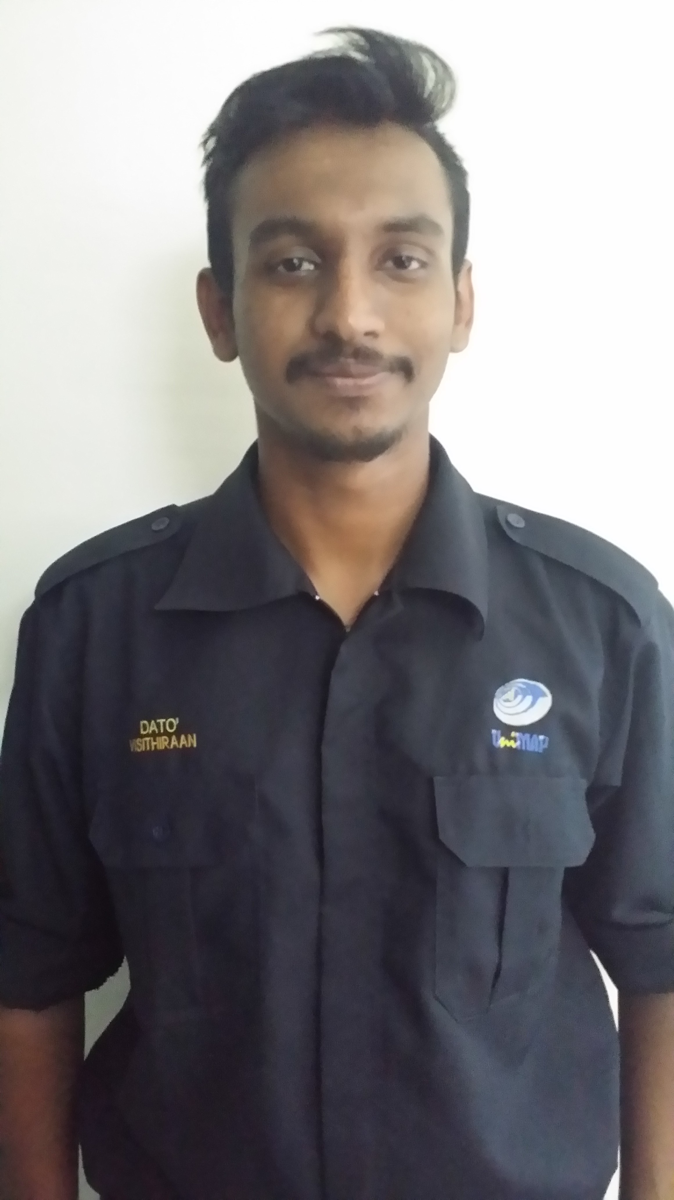

PICTURE
NAME:VISITHIRAAN A/L THANGAVEL
Last Update: 13 FEBRUARY 2017
Contact Info
Address | : | 48 jalan bidara 2 saujana utama 3 sungai buloh 47000 selangor
Mobile No. | : | 01136223957
Email | : | visithiraanthangavel@yaho.com
Personal Particulars
Age | : | 23 | Date of  Birth | :18 march 1994
Nationality | : | Malaysia | Gender | :Male
Marital Status | : | Single | IC No. | :940318145761
Permanent Residence | : | Malaysia
Educational Background
Highest Education
Level | : | Bachelor's Degree | Grade | : 3.23
Major | : | PHOTONICENGINEERING
Institute / University | : | UNIVERSITI OF MALAYSIA PERLIS(UNIMAP)
Located In | : | Malaysia
Languages
 | Proficiency (0=Poor - 10=Excellent)
Language | Spoken | Written
Bahasa Malaysia | 9 | 9
English | 9 | 9

Additional Info
Computer skills:

Microsoft Office

Borland Turbo 5 C++ programming

AutoCAD 1.3

Matlab 7.0

Scilab 7.1

Personal Qualities: I am easygoing person, have a good self-confident. I possessed excellent interpersonal skills, determined, creative and good in decision making and interacting with people at all level. I am computer literate and a fast-learner person.

Preferred Work Style: I would like to work in an organized environment, where I can be challenged to perform and be recognized for my performance. I would like to think that I am ambitious and realistic about my chances of completing a task successfully and contribute positively in company.

Subjects Taken Before Practical:

Computer Programming

Electric Circuit

Analog Electronics

Digital Electronics

Signal & System

Communication Systems

Microprocessor Systems

Control Systems

Electronic Instrumentation

Power Electronics

Ic Design

Advanced Optics

Photonic Material

Engineering Mathematics I, II & III

Seminar and extra curricular activities:

UNIVERSITY

- Involved in a Community Program organized by UNIMAP (16-21 SEPT 2015)
- Participated in Futsal competition organised by School of Microelectronic.
- Participated in Futsal competition organised by ICS.
- Participated in Handball competition organised by School of Microelectronic.
- Involved in a community programme (Perarakan HariMalaysia ke-52) organized by UNIMAP (16-21 SEPT 2015)

PRE UNIVERSITY(STPM)
- President of Majlis Pelajar Pra-u(MPPU)
- President of school sports team
- Treasurer of school scouts
- Attended a seminar entitled “Kewarganegaraan Hak dan Tanggungjawab Anjuran Yayasan 1Malaysia”(21st February 2013)

Working Experience

True fitness,Hartamas, Kuala Lumpur (May 2013)

Willing to Travel | : | Moderate (25% to 50%)
Willing to Relocate | : | Will Consider
Possess Own Transport | : | Yes

References
Name | : | IR DR NORSHAMSURI
Telephone No. | : | 012-6930039
Position | : | Lecturer and Industrial Training Programme Coordinator(PHOTONIC)
Company | : | UNIVERSITI MALAYSIA PERLIS
Name | : | DR NOR AZURA MALIKI BT AHMAD HAMBALI
Telephone No. |  | 016-4948176
Company | : | UNIVERSITI MAYSIA PERLIS

